Answers
Task 1 Run Length Encoding
The black and white image below contains 64 pixels.
1. How many bits would be used to represent the image? 64 bits.

2. The binary code for the first row would be 1111 1110 assuming white = 1 and black = 0.
How would the row be represented using Run Length Encoding?
71 10

3. Complete the pixel grid below using the following RLE frequency/data pairs.

21 10 21
21 20 11
50
21 20 11
21 10 21

Task 2
- The file RiverBMP is 696 kilobytes in size. Make use of an image editing program to investigate the effect of changing the resolution and colour depth of the image and complete the table below.
If you are in Windows, Microsoft Paint will be sufficient for this investigation. The filetypes to save as are shown here:
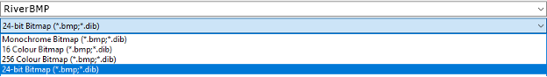
The dialogue box for changing the size is as follows:
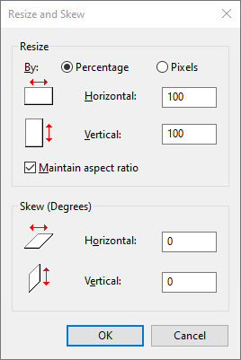

File name to save as and file properties | File size | Insert the image and describe the difference the changes have made
RiverBMP.bmp  650 × 365 | 696 kB | A good high quality image is seen  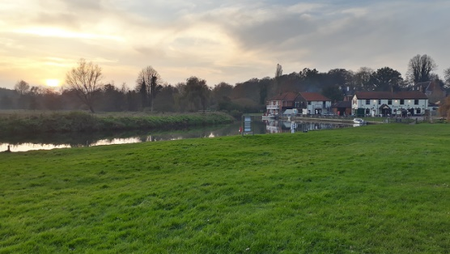
RiverBMP256.bmp  Reduce the colour depth to 256 colours (8 bit colour depth) | 234 kB | Colours are broadly an accurate representation, however, they do not have gradual changes – this is particularly true of the sky which should slowly fade from one colour to another.  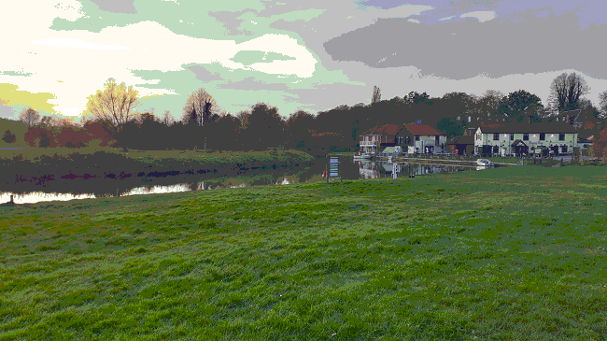
RiverBMP16.bmp  Reduce the colour depth to 16 colours (4 bit colour depth) | 118 kB | Colours do not accurately match the original colours. Very sudden changes in colour.  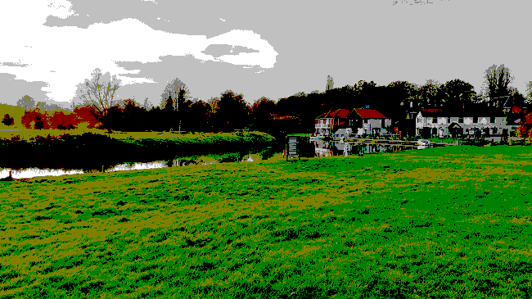
BeachBMP50percent resolution.bmp  Reduce the resolution of the image to 50 percent (325 × 183px) | 175 kB | The image is smaller as there are fewer pixels. If you zoom in to make it the same size it appears blurred/ out of focus.  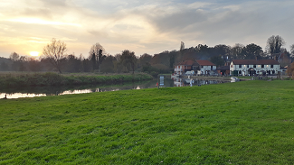
Students need to make sure they work from the original file when reducing colour depth or resolution (image dimensions/size). Students should be aware, by the end of the investigation, that they have permanently lost data when they re-save the files.
See the ‘RiverBMP answers’ folder for an example of the effects of the changes.
- Explain how the file size changes when the resolution (image dimensions) or colour depth are changed.
RiverBMP is a 24-bit colour depth image. To make 256 colours requires an 8-bit colour depth. So the file is one third the size. Equally, a 16 colour image requires just four bits per pixel, so this is half the size of the 256 (8-bit) colour image.
RiverBMP50percentresolution has 325x183 pixels = 59475 pixels.
RiverBMP has 650x365 pixels = 237250 pixels.
59475*100/237250 = 25.07% of the pixels. Therefore we would expect the file size to be 25.07% the size. 0.2507*696kB = 174.49 kB. (approx. 175 kB)
Note – the answers above are full explanations and calculations of the new storage sizes. Calculations of changes to colour depth and resolution are not given in the specification, but useful in understanding how properties affect file size.
Task 3
A piece of music is 39.79MB recorded at CD quality.
When compressed using the MP3 compression format, this becomes 3.6MB.
- Calculate the Internet download time for each file using a 24Mbps home connection and a 3G mobile connection. Use this website to help you. www.download-time.com
Quality | Download time at 24Mbps | Download time over 3G
CD | 13 Seconds | 46 Seconds
MP3 | 1 Second | 4 Seconds
2. Give two advantages of using a compressed music format for streaming music over an Internet data connection.
Faster streaming; less buffering.
Less data allowance is used on a pay-by-MB contract.

Task 4
For each of the scenarios below, suggest whether lossy or lossless compression should be used.
Use | Lossy / Lossless | Reason
A music track | Lossy | Some recorded sounds are not detectable by the human ear, and no noticeable difference will be heard if some sound data is lost. (Some music purists may prefer a lossless format.)
A text document | Lossless | All characters in a text document must be preserved.
A video clip | Lossy | Video data can easily be lost without affecting the quality too much.
A web image | Lossy | Images can still be recognised easily, even with the type of loss that the format uses.
A software application | Lossless | A software program may not run if a single character of data is missing.
A database | Lossless | Data must be reproduced exactly.

